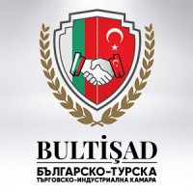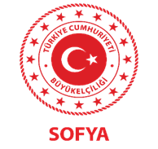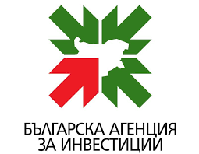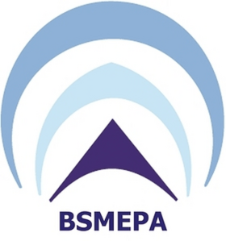

2nd Bulgarian-Turkish Business Forum

9-10 June 2023 | Regnum Hotel Bansko

Bulgarian-Turkish Chamber of Commerce and Industry has the pleasure to invite you to participate 2nd Bulgarian-Turkish business forum in Bansko which will be held on 9-10th of June. Тhe forum will focus on business opportunities and partnerships between the Balkan countries. The event will bring together a diverse range of businesses, entrepreneurs, investors, and policy-makers from Bulgaria, Turkey, and other Balkan countries to discuss and explore business opportunities in the region.
Program
9 June 2023 Friday
18:00 Networking Cocktail

10 June 2023 Saturday
Turkish companies will have exhibition stands which will be opened during the whole day
09:00-09:30 Registration
09:30-10:10 Welcome speeches (up to 5 minutes)
      - Burhan Nemutlu – Chairman of Management board of BULTISAD;
      - Bogdan Bogdanov – Executive director of Invest Bulgaria agency;
      - Boyko Takov – Executive director of Bulgarian SME agency;
      - Aylin Sekizkök – Ambassador of Republic of Turkey in Bulgaria

10:10-10:30 Café break
10:30-11:30 Round tables

- Energy moderator is the team of SeeNews
Participants
- Automotive moderator is the team of Automotive cluster Bulgaria
Participants
- European financing moderator is under discussion;
Participants:
Deloitte (Brussel funds)
Bulgarian SME agency – Kalin Marinov (National funds)
Bulgarian SME agency – Interreg program (BG&TR)
Lot consult (Erasmus+)

12:00-13:00 Lunch break
13:30-17:30 B2B meetings
20:00 Gala dinner

Date: 9-10th of June
Place: Regnum Bansko Hotel & Spa
Registration link: Втори Българо-Турски бизнес форум в Банско, 10 юни 2023/ 2nd Bulgarian-Turkish business forum in Bansko, 10 June 2023 (google.com)
Contact person: Maya Blaskova, office@bgtrchamber.com 00359896666103

